CERTIFICATE OF ATTENDANCE*
TEEN LEADER MINISTRY VOLUNTEER
SAFE ENVIRONMENT SESSION
(for persons pre-teen 11 & 12 Years Old )
(Please Print)

Pre-Teen’s Legal Name : DOB:

Telephone Number:
Name of Parish/School that pre-teen will volunteer : |  | City:
Home Session Date: | Name of Parent/Guardian Facilitator(s):

How will your pre-teen volunteer at your parish/school?

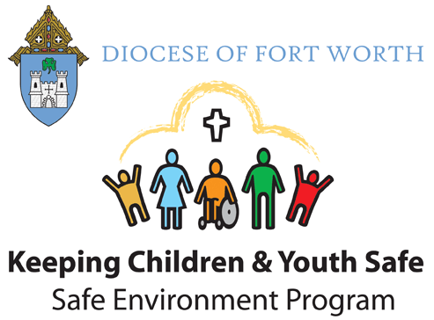
-------------------------------------------------------------------------------------------------------------------------------
CERTIFICATE OF ATTENDANCE*
TEEN LEADER MINISTRY VOLUNTEER SAFE ENVIRONMENT SESSION
(for persons pre-teen- 11 & 12 Years Old)

This certifies that___________________________________________________________
(Name)

satisfactorily completed the “Teen Leader Ministry Volunteer” Safe Environment Session for Pre-teens, identified by type above, at home with a parent/guardian facilitator:

Home Address: ______________________________________________City/Zip_____________

Session Date: _____________

*CERTIFICATE INVALID WITHOUT FACILITATOR’S SIGNATURE
Parent Facilitator ‘s Signature: | Facilitator’s Printed Name:

For Questions or Verification: Please Contact the Parish/School Office Hosting the Session at Phone
#940-565-1770, and Ask to Speak with the Safe Environment Coordinator. Thank You.

